📘 **SQL Project Report: CASE Statements for Conditional Transformation**

**Objective:**

This project leverages SQL CASE statements to:

Assign academic grades based on students' **TotalScore**.

Determine **Pass/Fail status** in individual subjects: **Math** and **Science**.

**Database Setup**

CREATE TABLE StudentScores ( StudentID INT, TotalScore INT, MathScore INT, ScienceScore INT );

INSERT INTO StudentScores (StudentID, TotalScore, MathScore, ScienceScore) VALUES (1, 95, 45, 50), (2, 85, 35, 60), (3, 75, 40, 30), (4, 65, 25, 20);

**Output**

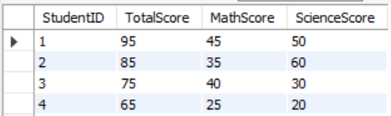

This table includes each student's ID, total score, and individual subject scores.

**1. Grade Assignment Based on Total Scores**

**Query Explanation**

Grades are assigned using the following brackets:

>= 90: Grade A

>= 80: Grade B

>= 70: Grade C

< 70: Grade D (Fail)

**Query**

SELECT StudentID, TotalScore, CASE WHEN TotalScore >= 90 THEN 'A' WHEN TotalScore >= 80 THEN 'B' WHEN TotalScore >= 70 THEN 'C' ELSE 'D (Fail)' END AS Grade FROM StudentScores;

**Output**

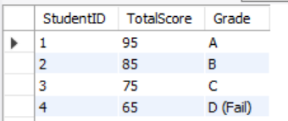

**Output Explanation**

Students were correctly classified based on their performance.

Each grade bracket includes one student in this dataset.

**2. Pass/Fail Status in Math and Science**

**Query Explanation**

Subject scores are evaluated individually:

**Pass**: Score >= 40

**Fail**: Score < 40

**Query**

SELECT StudentID, MathScore, CASE WHEN MathScore >= 40 THEN 'Pass' ELSE 'Fail' END AS MathStatus, ScienceScore, CASE WHEN ScienceScore >= 40 THEN 'Pass' ELSE 'Fail' END AS ScienceStatus FROM StudentScores;

**Output**

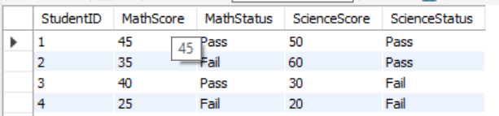

**Output Explanation**

Clearly shows which students passed or failed each subject based on the threshold.

**Summary & Insights**

* **Grade Distribution**:

1. A: 1 student
2. B: 1 student
3. C: 1 student
4. D (Fail): 1 student

* **Math Pass Rate**: 2 students passed, 2 failed
* **Science Pass Rate**: 2 students passed, 2 failed